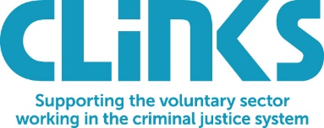
Clinks’ 23rd Annual General Meeting
Tuesday 23rd November 2021, online

NOTICE OF ANNUAL GENERAL MEETING NOVEMBER 2021

NOTICE IS HEREBY GIVEN that the 2021 Annual General Meeting of Clinks will be held online on Tuesday 23rd November 2021 at 1.30pm to transact the following business:

Ordinary Resolutions:

- That the minutes of the Annual General Meeting held on 22nd October 2020 be adopted as a true record of the meeting.

- That the audited Report and Financial Statements for the year ended 31 March 2021 for Clinks be received and adopted.

- The re-election of trustees of Clinks in accordance with Article 37 of the Articles of Association.
- The election of trustees of Clinks in accordance with Article 37 of the Articles of Association.

DRAFT AGENDA
- Welcome and Chair’s address – Roma Hooper

- Apologies from members

- Approval of minutes of the 22nd AGM held on 22nd October 2020

Ordinary Resolution 1:
That the minutes of the Annual General Meeting held on 22nd October 2020 be adopted as a true record of the meeting.

- Presentation of the Annual Report & plans for the future - Anne Fox, Chief Executive Officer

- Presentation of the Annual Accounts

Ordinary Resolution 2:
That the audited Report and Financial Statements for the year ended 31 March 2021 for Clinks be received and adopted.

- Resignation, re-election and election of trustees

Ordinary Resolution 3:
That the following trustees be re-elected as trustees of Clinks in accordance with Article 37 of the Articles of Association:

- Roma Hooper

Ordinary Resolution 4:
That the following individuals are elected as trustees of Clinks:

- Richard Booty
- Simon Ruding

- Close

By order of the Board
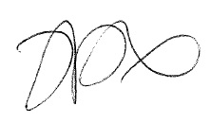
Anne Fox
Chief Executive Officer and Company Secretary

20th October 2021
Registered Office: Clinks, Block C, 5th Floor, Tavistock House, Tavistock Square, London, WC1H 9JJ
In accordance with s.324 of the Companies Act 2006 as a member of the Company you are entitled to appoint a proxy to exercise all or any of your rights to attend, speak and vote at the Meeting. The proxy form is attached to the email and should be returned to Clinks by Monday 15th November 2021.

