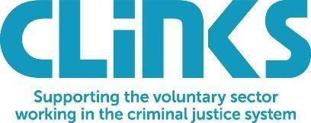
Covid-19 winter support grants - eligibility criteria
December 2020

The organisation
- Voluntary organisations operating in England and Wales, supporting people in prison, through-the-gate, or in the community (under licence or serving a community sentence).
- ‘Voluntary organisations’ means any registered charity or incorporated social enterprise.
- Organisations must have an annual income not exceeding £250,000.
- Organisations must not be in receipt of funding from any other source for the same activities as this funding will support. (I.e. any other government Covid-19 related relief, grant, intervention or other measure which results in the voluntary sector recipient receiving more than one benefit/relief for the same underlying cash-flow issue).
- Organisations should have an up-to-date listing on Clinks’ Directory of Offender Services for the activities supported under this programme. Find out how to do this here.

The service
- Services should be within the scope of HMPPS’s work (i.e. for adults or young offenders in custody, or over-18s on licence or on community orders). Please note that the following service types are not eligible for this funding: services for under-18s who are not in custody, and services for the families of an individual in the criminal justice system which do not also offer direct support to the individual.
- Services funded should not be those expected to be provided by Community Rehabilitation Companies, but can complement them or provide support in accessing their services if this is limited by the Covid-19 crisis.

The grants
- Organisations must agree to assess the benefit of the grant to their beneficiaries and submit a short report at the end of the programme.
- Organisations must spend all monies by 31st March 2021.

